1. **Project Title**

Income Expense Tracking System

1. **GitHub Repo Link:** https://github.com/MinetaKun/22067495-Kishor-GC-Income-Expense-Tracking-System
2. UI Design (Wireframe)
3. Login Page



1. Dashboard

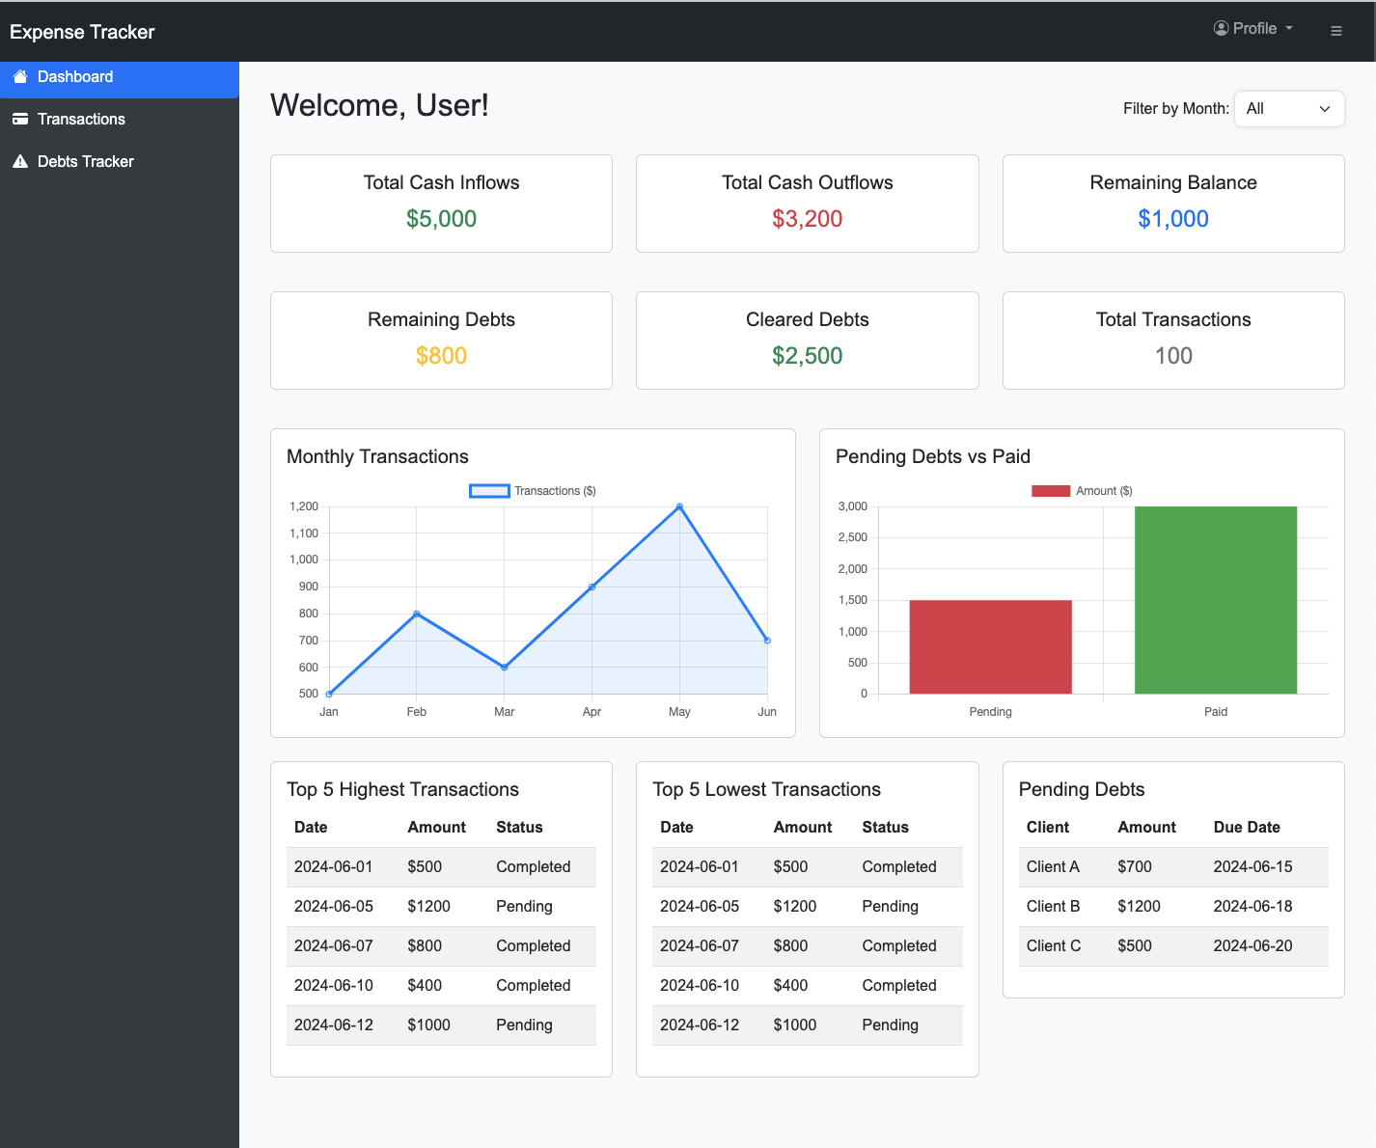

1. Transactions Page

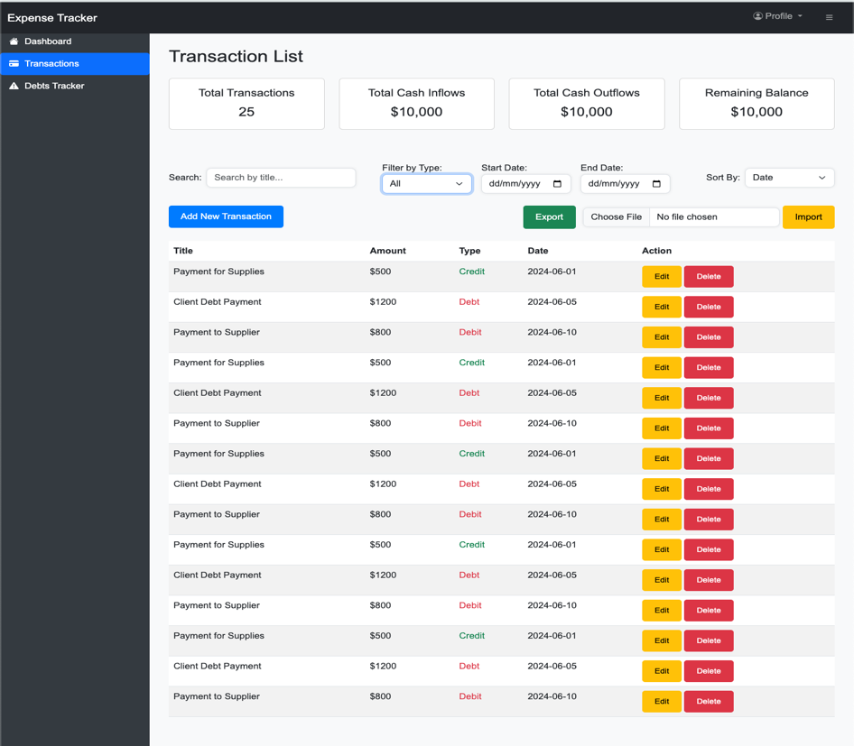

1. Add Transaction Page

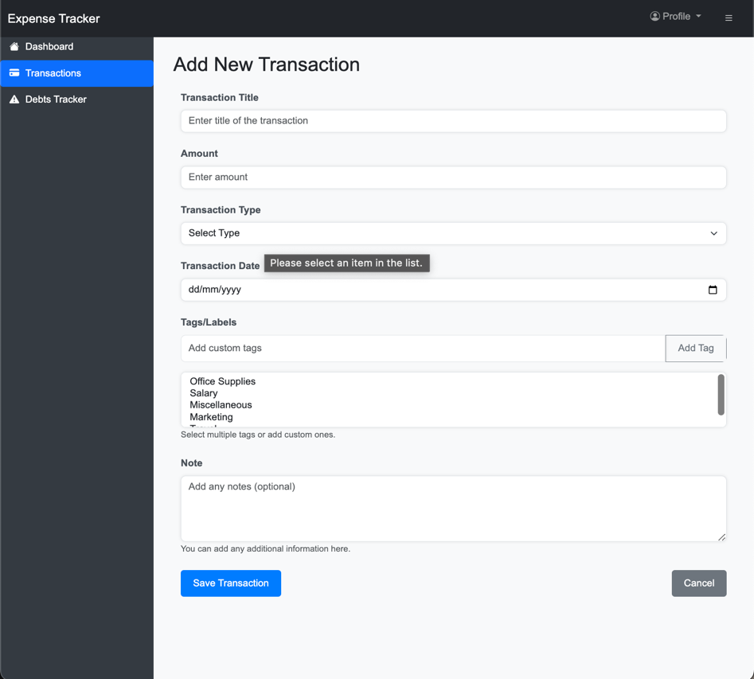

1. Debts Tracker Page

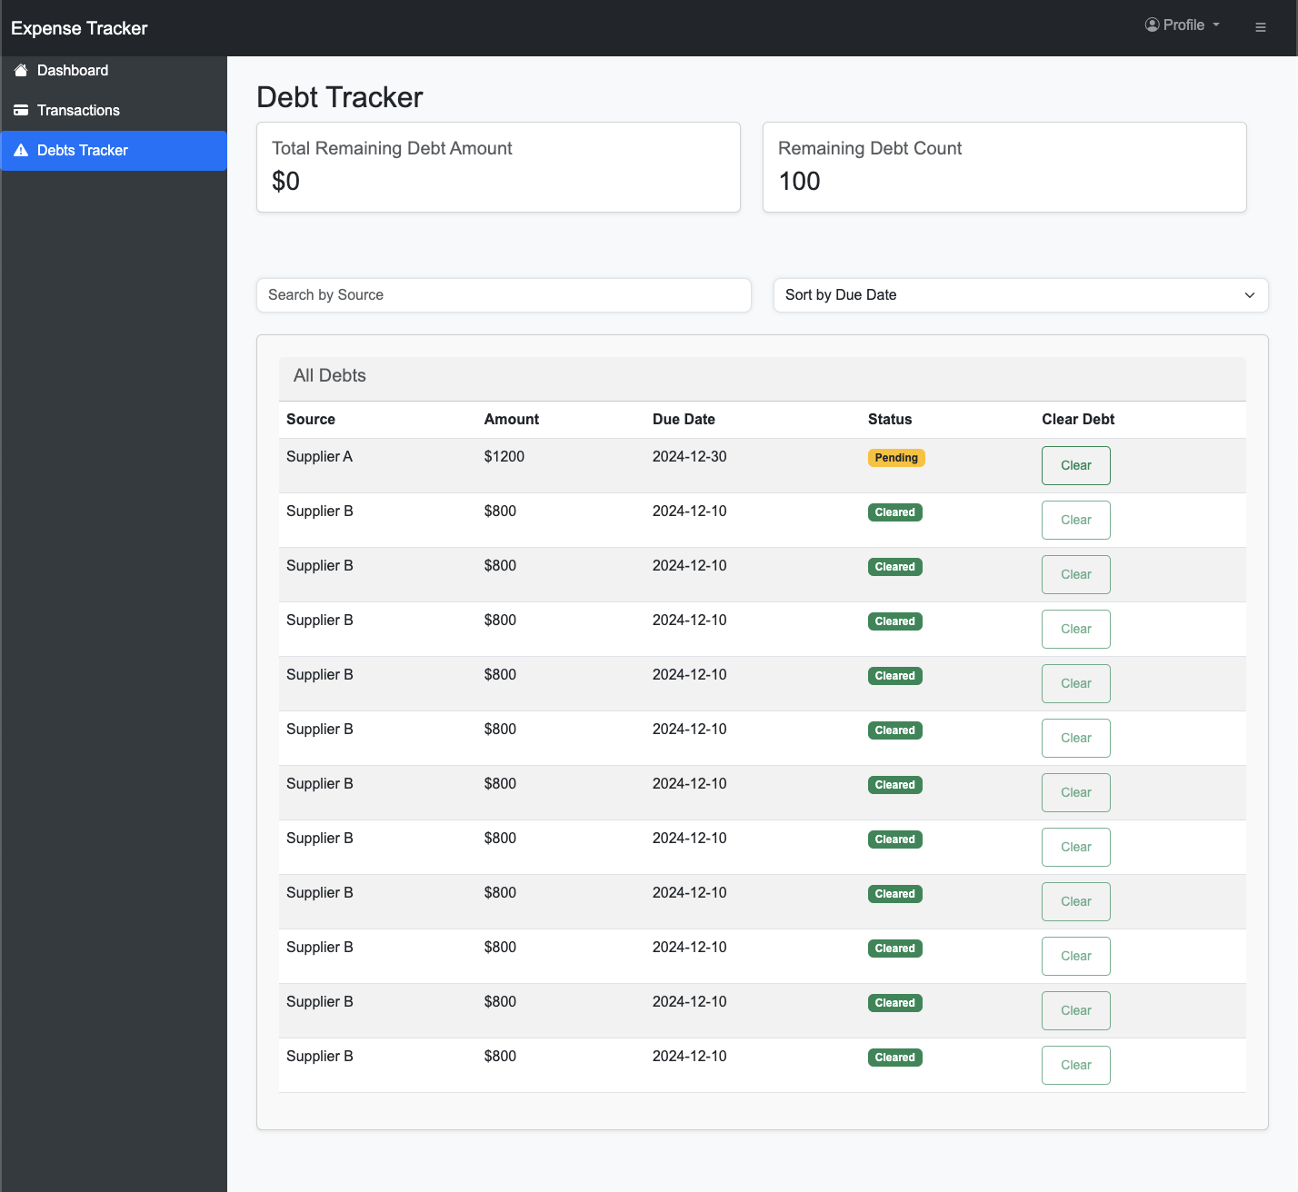

4. Data/Entity Modeling

1. Login

Username (String)

Password (String)

Select Currency (String)

2. Transactions

Transaction ID (Integer)

Type (String)

Amount (Float)

Date (Date)

Source/Purpose (String)

Description (String)

3. Debts

Debt ID (Integer)

Source of Debt (String)

Amount (Float)

Due Date (Date)

Status (String)

Cleared From (String)

1. Technology Stack
2. **Framework :** MAUI Blazor Hybrid

                                          ii) **External Libraries** MudBlazor

                                         iii) **Persistence Mechanism**: File Handling will be done is CSV format.